COMP7013 Object Oriented Programming.

Assignments/ Practical/Skills Evaluation. 30%

Due dates end of week3, week 5, week 7.

## On completion please zip up your files including any documents used for drawing the class diagram. Upload to Canvas. This zip file should include all Labs and a screen-cast-o-matic of the code working or preferably do a demo I the lab time.

My Covid close contact Application.

I want to develop an application to keep track of close contacts for a people in order for a person to be able to inform people (close contacts) that they may be at risk of Covid when/if the person tests positive for Covid. I want is to be able to get a list of the contacts for a person since a certain date.

Use an arraylist of Contact objects.

Write a javafx desktop application with a Gui see the GUI below as a Guide. Improve on it maybe.

Do not use “Scene Builder” use objects. its an exercise in using objects from a pre-existing java-API.

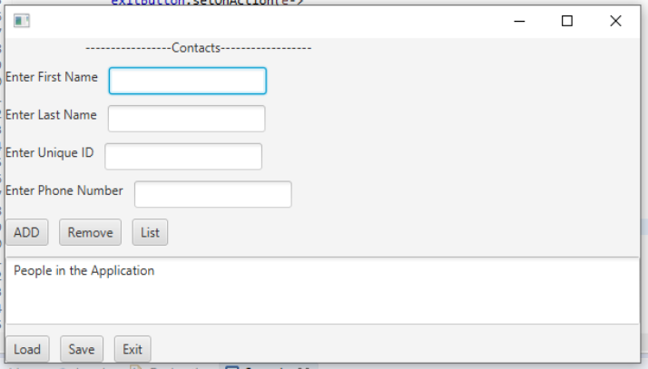

Part 1. Week 3 (10 Marks)

Use an arraylist of objects(Contacts) to store the information inputted by the Add button above.

Display all information in the text area. It contains the text from the arraylist of Contacts.

A contact can be removed from the arraylist.

List updates the list of Contacts displayed (with no totals)

Load and save do as they imply: load and save the information to or from a file. Load automatically on startup. Ask user to save or not on exit. Move the Exit button so that it appears on the lower right side of the GUI.

Part 2. Week 5 (10 Marks)

Change the application so that it uses a Tabbed pane.

* Tab 1 will be an intro tab it allows for adding Contacts as above.
* Tab 2 will record a close contact between two people at a specific time and date. You will be able to select each contact (From drop down list or other) and enter a date and time.
* Tab 3 hopefully will never be used this will be the tab for finding contacts for a Covid positive person. Here I want to see all the close contacts. Make sure you use a good layout for the items on each tab. Do not make it too simple.

Part 3. Week 7 (10 Marks)

Show the use of the following in your previous application:

* Ordering in tab3 order on date or Name depending on a users request/button.
* In tab 2 Contacts should be selected from a drop down list or similar to reduce the possibility of an entry error.
* Use Serialization for Save the contact details using serialization to a file.
* A good package structure (Maybe use Mavin)
* MVC must be used.
* Generate an executable jar file
* Create a non-executable jar file (as simple as you like) import it and use it in your project, use any class you wish just import at least one class.